Name of Student: Akshit Kumar | PRN:25070122270
Semester: III | Year : AY 2026-27
Subject: Programming with Java
ASSIGNMENT No : 9
TITLE : Final Keyword in Java
Problem Statement
Write a Java program to demonstrate the use of the final keyword with variables, methods, and classes.
Learning Objectives
To implement the final keyword with variables, methods, and classes.

Programme
- Create a Bank Account program where account number is final and cannot be changed.
class BankAccount {

final long accountNumber;
String accountHolder;
double balance;

BankAccount(long accountNumber, String accountHolder, double balance) {
this.accountNumber = accountNumber;
this.accountHolder = accountHolder;
this.balance = balance;
}

final void displayAccount() {
System.out.println("Account Number: " + accountNumber);
System.out.println("Account Holder: " + accountHolder);
System.out.println("Balance: " + balance);
}
}

final class BankRules {
void displayRule() {
System.out.println("Account number cannot be changed.");
}
}

public class bank {
public static void main(String[] args) {

BankAccount account = new BankAccount(
1234567890L,
"Akshit",
25000
);
account.displayAccount();
BankRules rules = new BankRules();
rules.displayRule();
}
}
- Create a Library Book Management program where the book ISBN is declared as final and cannot be changed once assigned. Display the book's ISBN, title, author, and price.
class Book {
final String ISBN;
String title;
String author;
double price;

Book(String ISBN, String title, String author, double price) {
this.ISBN = ISBN;
this.title = title;
this.author = author;
this.price = price;
}

void displayBook() {
System.out.println("ISBN: " + ISBN);
System.out.println("Title: " + title);
System.out.println("Author: " + author);
System.out.println("Price: " + price);
}
}

public class library{
public static void main(String[] args) {

Book book = new Book(
"978-0135166307",
"Effective Java",
"Joshua Bloch",
850.00
);

book.displayBook();
}
}
Output
1)
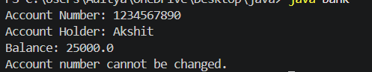
2)
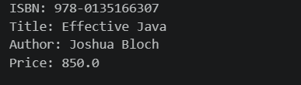

Conclusion
Both the Bank Account and Library Book Management programs successfully demonstrate the use of the final keyword in Java. The final variables ensure that important values such as the account number and book ISBN cannot be changed once assigned. These programs demonstrate how final helps maintain data security, consistency, and code reliability.

